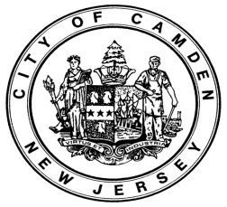

**MUNICIPAL BOARD OF ALCOHOLIC BEVERAGE CONTROL**

**REGULAR MEETING**

**Monday, September 16th, 2024 - 5:00 P.M.**

**Call to Order**

**Flag Salute**

**Notice of Meeting**

**Roll Call**

**AGENDA**

**READING OF SUNSHINE LAW**

In conformance with the Sunshine Law of New Jersey, notice of the meeting was posted in the Municipal Clerk’s Office on **September 13th, 2024**

**APPROVAL OF THE MINUTES**

* The minutes for the July 8th, 2024 meeting
* The minutes for the August 19th, 2024 meeting

**COMMUNICATIONS**

**CLOSED SESSION**

**N/A**

**NOTICE TO APPEAR**

N/A

**DISCIPLINARY HEARING**

N/A

**PENDING TRANSFERS**

* Received person to person and place to place transfer (expansion) for **D. Utley LLC t/a Charlie’s Place** **0408-33-022-005 (ready pursuant to Clearance Cert)**
* Received person to person transfer **JLV Restaurant Group Inc. t/a Old San Juan** **0408-33-170-010 (Not ready)**
* Received person to person transfer for **783 Bar Inc., to Poole’s Liquor** LLC **0408-32-153-002 (Not ready)**
* Received a person to person transfer from **Romans Waldorf LLC** to **O’Reilly Liquors LLC 0408-33-176-009 ( Not ready)**

**PUBLIC FORUM**

**ADJOURNMENT**